|  |  |  |  |  |
| --- | --- | --- | --- | --- |
| Prescriptive Analytics - HW 7 | | |  |  |
| Saundarya Badhrinathan, Nabeel Ahmed, Divya Chandramohan, | | | |  |
| Uttara Thiagarajan, Megan Mugavero | | |  |  |
| 1. | Readings completed | |  |  |
| 2. | John’s Problem: | |  |  |
|  | Payoff Matrix: | |  |  |
|  |  |  |  |  |
|  |  |  | Re-Elected | Not re-elected |
|  |  |  |  |  |
|  | Sell half of the business |  | 480,000 | 70,000 |
|  |  |  |  |  |
|  | Sell entire business |  | 260,000 | 260,000 |
|  |  |  |  |  |

Maxi-Min & Maxi-Max Approaches:

|  |  |  |  |  |  |  |  |  |  |  |  |  |  |  |
| --- | --- | --- | --- | --- | --- | --- | --- | --- | --- | --- | --- | --- | --- | --- |
|  |  | Re-Elected | | Not re-elected | |  | Maxi-Min | |  |  |  | Maxi-Max | | |
|  |  |  |  |  |  |  |  |  |  |  |  |  |  |  |
| Sell half of the |  | 480,000 | | 70,000 |  |  | 70,000 |  |  |  | 480,000 | | |  |
| business |  |  |  |  |  |  |  |  |  |  |  |  |  |  |
|  |  |  |  |  |  |  |  |  |  |  |  |  |  |  |
| Sell entire |  | 260,000 | | 260,000 |  |  | 260,000 |  |  |  | 260,000 | | |  |
| business |  |  |  |  |  |  |  |  |  |  |  |  |  |  |
|  |  | |  |  |  |  |  |  |  |  |  |  |  |  |
| Mini-Max Regret Approach: | | | |  |  |  |  |  |  |  |  |  |  |  |
|  |  |  |  |  |  | | | |  |  | | |  | |
|  |  |  | Re-Elected |  | Not re-elected | | | |  | Mini-Max Regret | | | | |
|  | |  |  |  |  | |  |  |  |  | | |  |  |
| Sell half of the | |  | 0 |  | 190,000 | |  |  | 190,000 | | | |  |  |
| business | |  |  |  |  |  |  |  |  |  |  |  |  |  |
|  | | |  |  |  |  |  |  |  |  | | |  |  |
| Sell entire business | | | 220,000 |  | 0 |  |  |  | 220,000 | | | |  |  |
|  | |  |  | |  | | | |  |  | | |  | |
| Maxi-Min: | |  | $260,000 payoff ​**(Decision: Sell the entire business)** | | | | | | | | | | | |
| Maxi-Max: | |  | $480,000 payoff ​**(Decision: Sell half of the business)** | | | | | | | | | | | |
| Mini-Max Regret: | |  | $190,000 ​**(Decision: Sell half of the business)** | | | | | | | | | | | |

MO: 0.65(Not re-elected) > 0.35(Re-elected) → $260,000 > $70,000

**(Decision: Sell his entire business)**

|  |  |  |  |  |  |  |  |  |
| --- | --- | --- | --- | --- | --- | --- | --- | --- |
| EV: | Sell half of the business → | 0.35($480,000)+0.65($70,000) | |  | = $213,500 | | | |
|  | Sell entire business → | 0.35($260,000)+0.65($260,000) | | | = $​260,000 | | | |
|  | **(Decision: Sell his entire business)** | |  |  |  |  |  |  |
| ER: | Sell half of the business → | 0.35($0)+0.65($190,000) | = $123,500 | | | | |  |
|  | Sell entire business → | 0.35($220,000)+0.65($0) | = ​$77,000 | | | | | |
|  | **(Decision: Sell his entire business)** | |  |  |  |  |  |  |
| Expected payoff with PI | | = 0.35($480,000)+0.65($260,000) = $337,000 | | | | | |  |
| Expected payoff based on EV | | = $260,000 |  |  |  |  |  |  |
| EVPI |  | = |$337,000 - $260,000| = $77,000 (Equal to ER) | | | | | | |

**(Decision: John should accept the offer)**

3. Decision Tree:

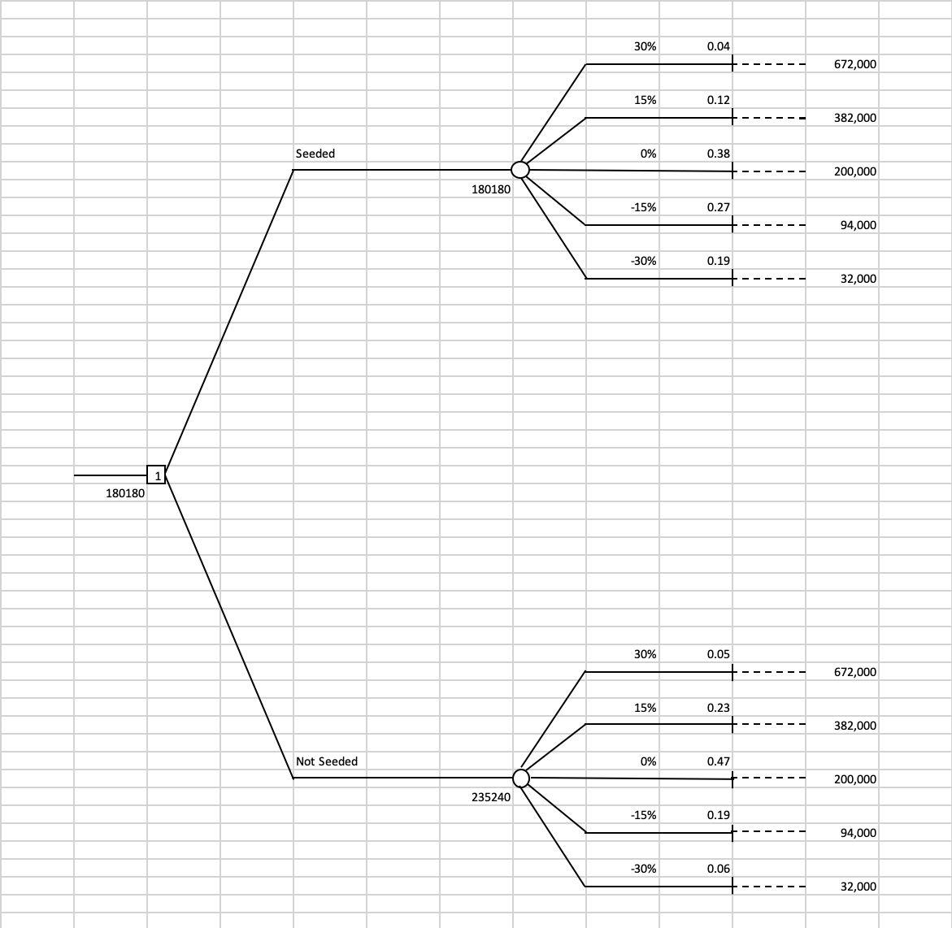

Property damage from seeding is lower.

4. Decision Tree:

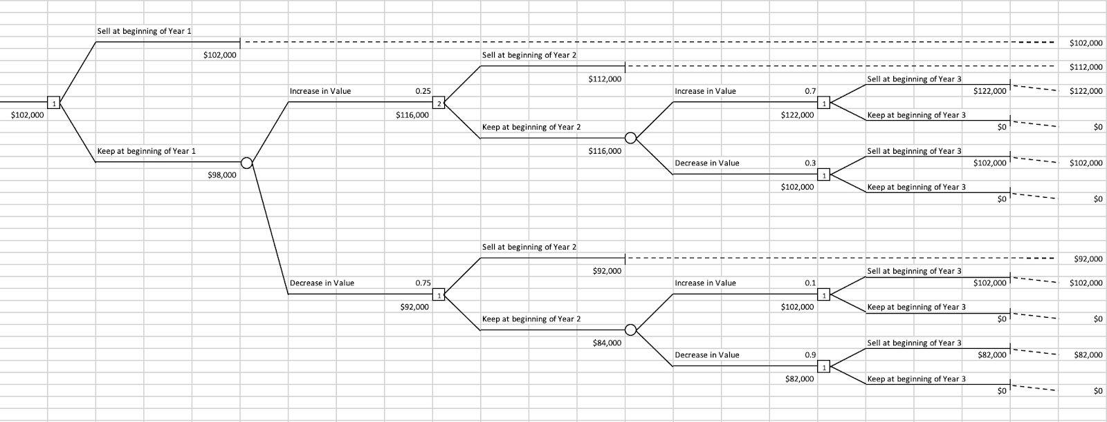

Decision: Sell at beginning of Year 1

5.

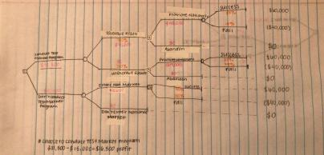

6.

|  |  |  |
| --- | --- | --- |
| **Path** | **Length** | **Slack** |
|  |  |  |
| 1-2-3-8-9 | 3+7+9+3 = 22 | 30 - 22 = 8 |
|  |  |  |
| 1-2-3-7-8-9 | 3+7+7+7+3 = 27 | 30 - 27 = 3 |
|  |  |  |
| 1-2-4-5-6-7-8-9 | 3+5+3+4+3+7+3 = 28 | 30 - 28 = 2 |
|  |  |  |
| 1-2-4-5-7-8-9 | 3+5+3+8+7+3 = 29 | 30 - 29 = 1 |
|  |  |  |

|  |  |  |
| --- | --- | --- |
| 1-2-4-5-8-9 | 3+5+3+8+3 = 22 | 30 - 22 = 8 |
|  |  |  |
| 1-2-5-6-7-8-9 | 3+9+4+3+7+3 = 29 | 30 - 29 = 1 |
|  |  |  |
| 1-2-5-7-8-9 | 3+9+8+7+3 = ​**30** | 30 - 30 = 0 |
| 1-2-5-8-9 | 3+9+8+3 = 23 | 30 - 23 = 7 |
|  |  |  |

1. Critical path: 30
2. Critical activities: 1-2-5-7-8-9
3. 30 weeks
4. See aforementioned chart for answers
5. Yes, Activity I is a critical activity; any delays to a critical activity will lengthen the projoect duration
6. No, Activity L is not a critical activity; any delays to a noncritical activity won’t lengthen the project duration

7.

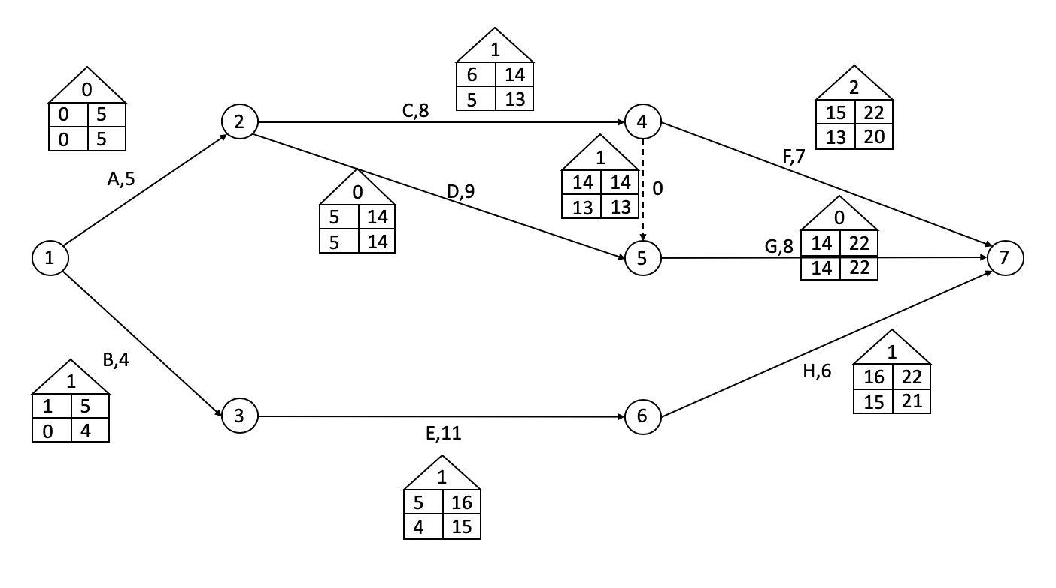

Critical Activities: A (1-2), D (2-5), G (5-7)

Critical Path: 1-2-5-7

Project Duration: 22 days

8.

(1)

Minimize Z = XJ

Subject to:

XA = 0

XB-XA ≥ 0

XC-XB ≥ 0

XD-XA ≥ 0

XE-XC ≥ 0

XF-XE ≥ 0

XG-XD ≥ 0

XH-XE ≥ 0

XI-XH ≥ 0

XI-XG ≥ 0

XJ-XF ≥ 0

XJ-XI ≥ 0

XA, ... , XJ ≥ 0

(2) .

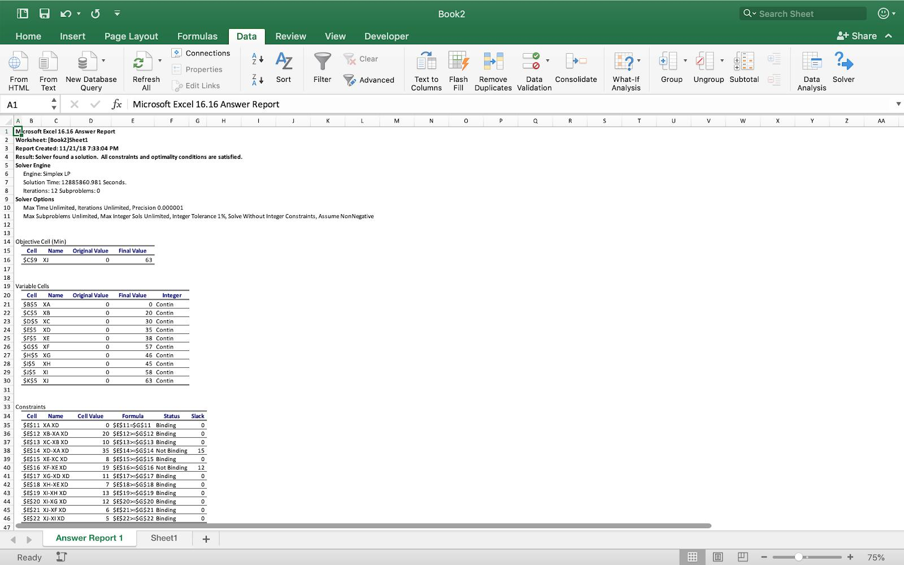

(3) Yes, the project durations match for both methodologies